Y1 ADDITION
MENTAL METHODS  WITH JOTTINGS | Counting on from the largest number in ones.  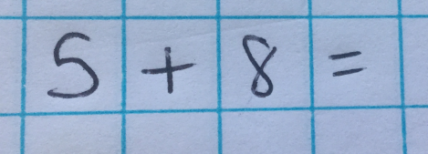  *Some children will naturally visualise bridging through ten. This can be demonstrated using Tens frames and number lines.  8 + 2 = 10  10 + 3 = 13 |  |  | Children need to memorise number bonds to 20 and relate addition to subtraction.  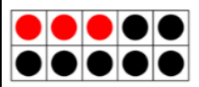  3 + 7 = 10  7 + 3 = 10  10 – 7 = 3  10 – 3 =7  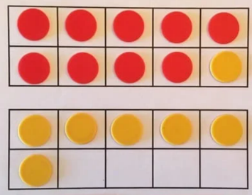  9 + 7 =  10 + 6 = 16 |  | Finding near doubles.  8 + 9 =  Double 8 = 16  16 + 1 = 17
MENTAL METHODS  WITH JOTTINGS | 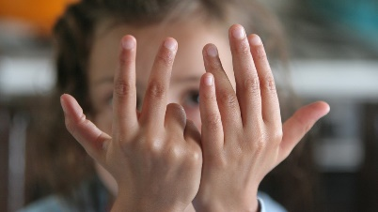  1) Children put largest number (8) in their head.  2) They raise the appropriate number of  fingers: 5 ones  3) They count on and put fingers down as  they count.  4) Record the total. |  |  | Use Tens frames to visualise number bonds. |  | Children record jottings if necessary.
MISSING NUMBER  CALCULATIONS | Whole Part Models  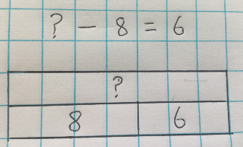  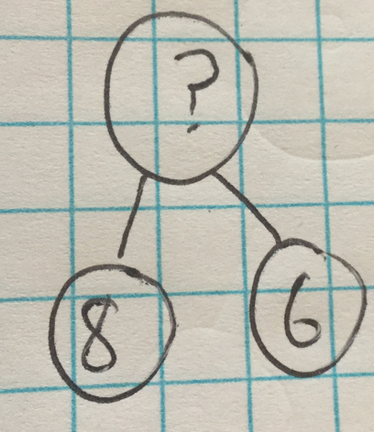 |  |  |  | Whole part models are especially useful when calculating the missing number in a calculation.  This model helps children to understand that this calculation requires addition even though there is a subtraction sign.
Y2 ADDITION
MENTAL METHODS  WITH JOTTINGS | Counting on in ones from the largest number.  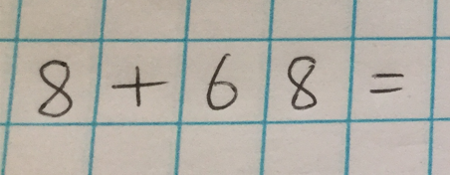  *Some children will naturally visualise bridging through ten. This can be demonstrated using Tens frames and number lines.  68 + 2 = 70  70 + 6 = 76 |  | 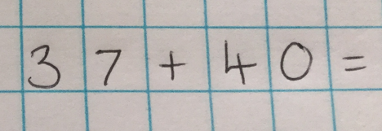  Adding Tens |  |  |  | 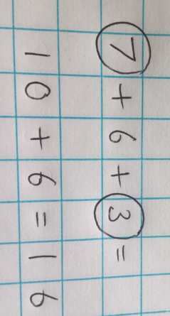  Spotting Number Bonds
MENTAL METHODS  WITH JOTTINGS |  |  |  |  |  |  | Finding Near Doubles.  31 + 33 =  Double 30 = 60  60 + 4 = 64
MENTAL METHODS  WITH JOTTINGS |  |  |  |  |  |  | Adjusting (useful when adding numbers ending in 9)  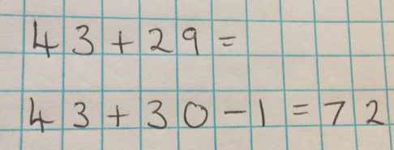
MENTAL METHODS  WITH JOTTINGS | 1) Children put largest number in their head (68).  2) They raise the appropriate number of  fingers: 8 ones as in above  example.  3) They count on and put fingers down as  they count.  4) Record the total. |  | - Children put the starter number in their  head (37).  - They raise the appropriate number of fingers: 4 tens as in the above example.  - They count on in tens and put the fingers down as they count.  - Record the total. |  |  |  | Children record jottings if necessary. They can be supported initially with a hundred square but the aim is to calculate mentally.
FORMAL WRITTEN  METHODS | Adding two 2-digit numbers: Empty Number line  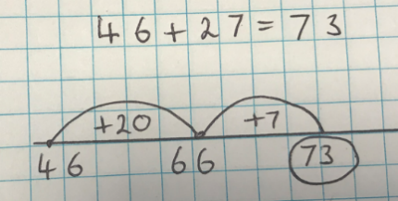 |  |  |  | Adding two 2-digit numbers: Formal Method  (taught from Spring Term)  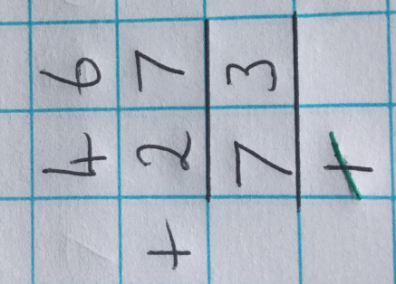
FORMAL WRITTEN  METHODS | - Start with the largest number.  - Count on in tens  - Then count on in ones.  - Record the total. |  |  |  | - Numbers are carried to the bottom when completing addition calculations.  - Children should cross off carried numbers as they complete the calculation with a neat line.  - Digits should be referred to by their value: 6 in the tens column is 6 TENS or 60 not 6.
MISSING NUMBER  CALCULATIONS | Whole Part Models  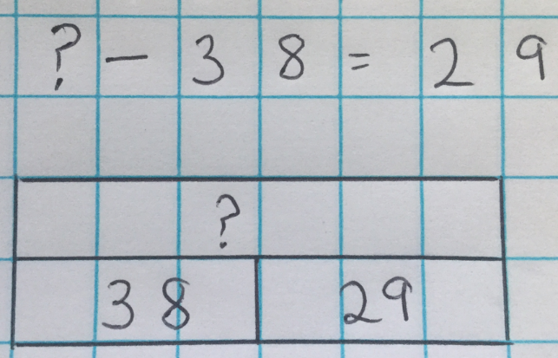  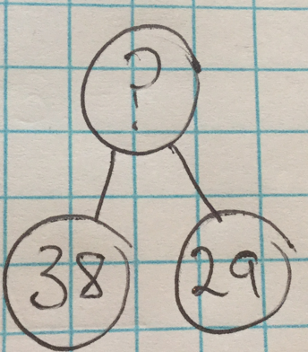 |  |  |  | Whole part models are especially useful when calculating the missing number in a calculation.  This model helps children to understand that this calculation requires addition even though there is a subtraction sign.
Adding in different contexts:  Examples of KS1 SATs questions involving addition. | 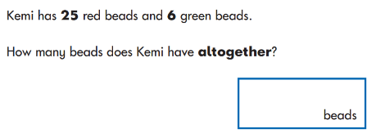 | 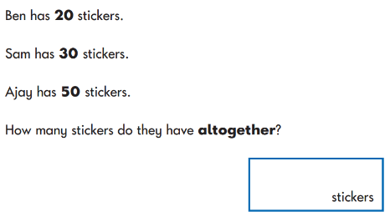 |  |  | 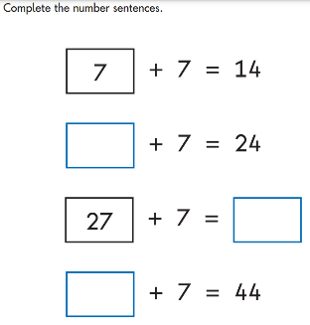 |  |  | 

