Y3 ADDITION
MENTAL METHODS  WITH JOTTINGS | Counting on from the largest (or starter) number in ones, tens and hundreds.  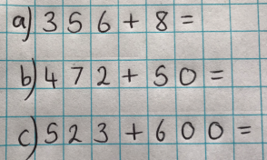 |  |  |  | Finding near doubles.  76 + 78 =  Double 70 = 140  140 + 14 = 154 |  |  |  |  |  | Adjusting  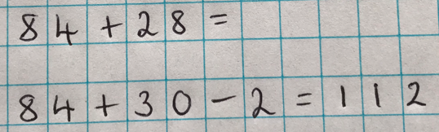
MENTAL METHODS  WITH JOTTINGS | 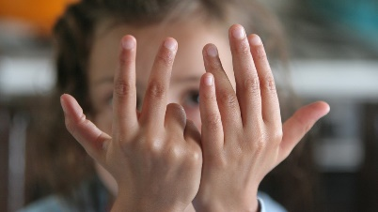  1) Children put largest or starter number in their head.  2) They raise the appropriate number of  fingers: 8 ones. 5 tens, 6 hundreds (as in  the examples above)  3) They count on and put fingers down as  they count.  4) Record the total. |  |  |  | Children record jottings if necessary. |  |  |  |  |  | Children record jottings if necessary.
FORMAL WRITTEN  METHODS | 3-digit add 2-digit, 3-digit add 3-digit  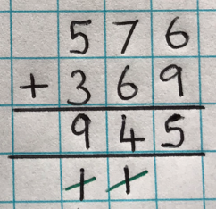  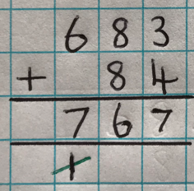 |  |  |  |  |  | - Children should be encouraged to estimate BEFORE calculating.  - Numbers are carried to the bottom when completing addition calculations.  - Children should cross off carried numbers as they complete the calculation with a neat line.  - Digits should be referred to by their value: 6 in the Tens column is 6 TENS or 60 not 6.  - Children should be encouraged to check their answer using the inverse subtraction calculation.
MISSING NUMBER  CALCULATIONS | Whole Part Models  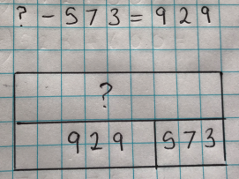  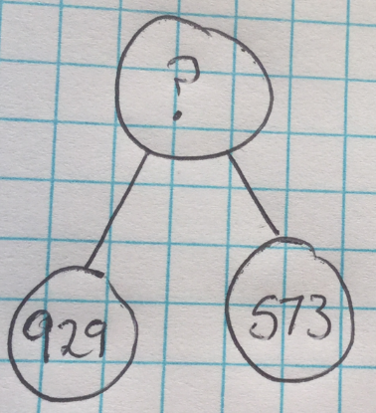 |  |  |  |  |  | Whole part models are especially useful when calculating the missing number in a calculation.  This model helps children to understand that this calculation requires addition even though there is a subtraction sign.
Y4 ADDITION
MENTAL METHODS  WITH JOTTINGS | Finding Near Doubles  86 + 79 =  Double 80 = 160  160 + 6 – 1 = 165 |  |  | 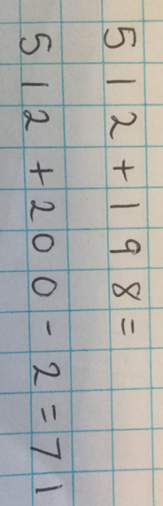  Adjusting  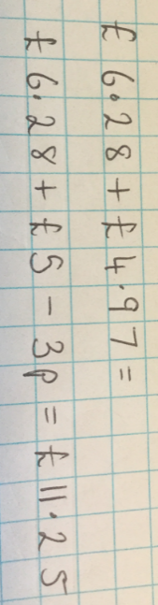 |  |  |  |  |  | Empty number lines are useful when counting on through zero and when increasing time.  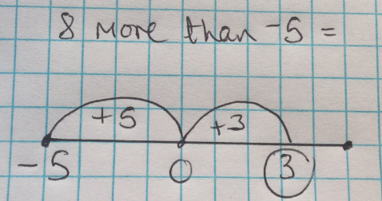  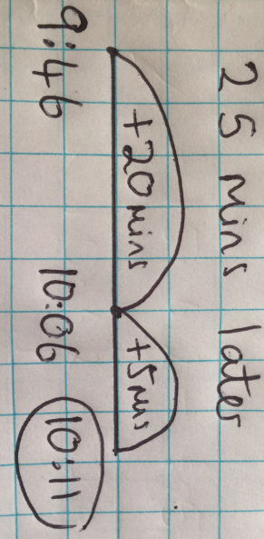
MENTAL METHODS  WITH JOTTINGS | Children record jottings if necessary. |  |  | Children record jottings if necessary. |  |  |  |  |  | Children record jottings if necessary.
FORMAL WRITTEN  METHODS | 4-digit add 2-digit, 4-digit add 3-digit, 4-digit add 4-digit  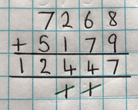  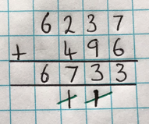  Decimals to 2DP  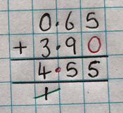  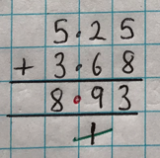  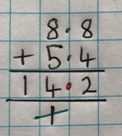 |  |  |  |  |  | - Children should be encouraged to estimate BEFORE calculating.  - Numbers are carried to the bottom when completing addition calculations.  - Children should cross off carried numbers as they complete the calculation with a neat line.  - Digits should be referred to by their value: 6 in the Tens column is 6 TENS or 60 not 6.  - Children should be encouraged to check their answer using the inverse subtraction calculation.  - When adding decimals of different decimal places mark the spaces with zeros.
MISSING NUMBER  CALCULATIONS | Whole Part Models  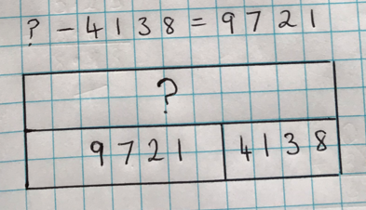  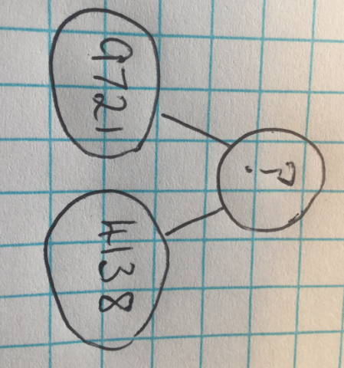 |  |  |  |  |  | Whole part models are especially useful when calculating the missing number in a calculation.  This model helps children to understand that this calculation requires addition even though there is a subtraction sign.
Y5 ADDITION
MENTAL METHODS  WITH JOTTINGS |  | Finding Near Doubles  380 + 380 =  Double 400 – 40 = 760  1.5 + 1.6 =  Double 1.5 + 0.1 = 3.1 | Adjusting  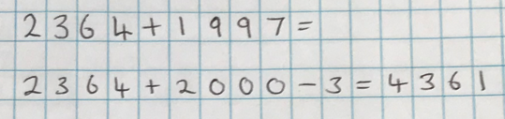  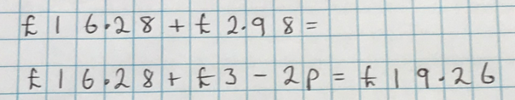  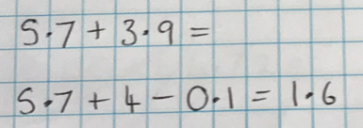 |  |  |  |  |  | Empty number lines are useful when counting on through zero and when increasing time.  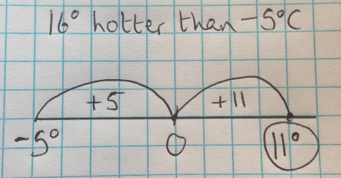  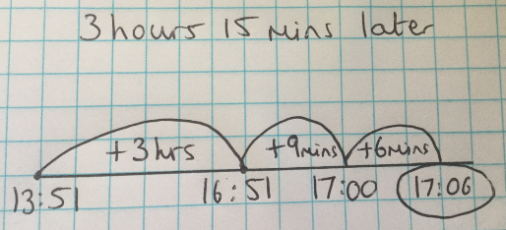
 |  | Children record jottings if necessary. | Children record jottings if necessary. |  |  |  |  |  | Children record jottings if necessary.
FORMAL WRITTEN  METHODS |  | More than 4 digits  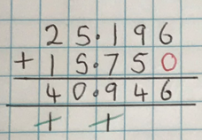  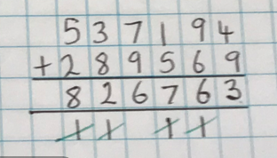  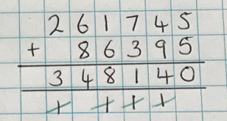  Decimals to 3D  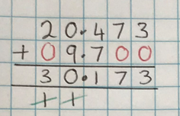 |  |  |  |  |  |  | - Children should be encouraged to estimate BEFORE calculating.  - Numbers are carried to the bottom when completing addition calculations.  - Children should cross off carried numbers as they complete the calculation with a neat line.  - Digits should be referred to by their value: 6 in the tens column is 6 TENS or 60 not 6.  - Children should be encouraged to check their answer using the inverse subtraction calculation.  - When adding decimals of different decimal places mark the spaces with zeros.
MISSING NUMBER  CALCULATIONS |  | Whole Part Models  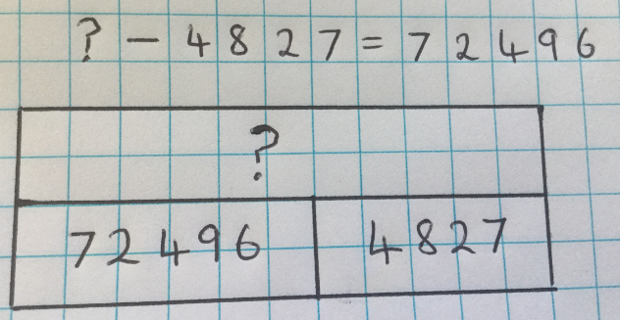  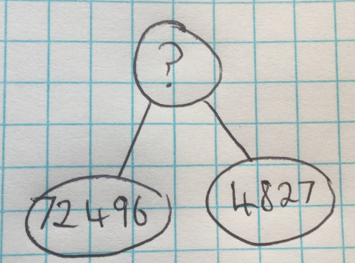 |  |  |  |  |  | Whole part models are especially useful when calculating the missing number in a calculation.  This model helps children to understand that this calculation requires addition even though there is a subtraction sign.
Y6 ADDITION
As in Y5 and:  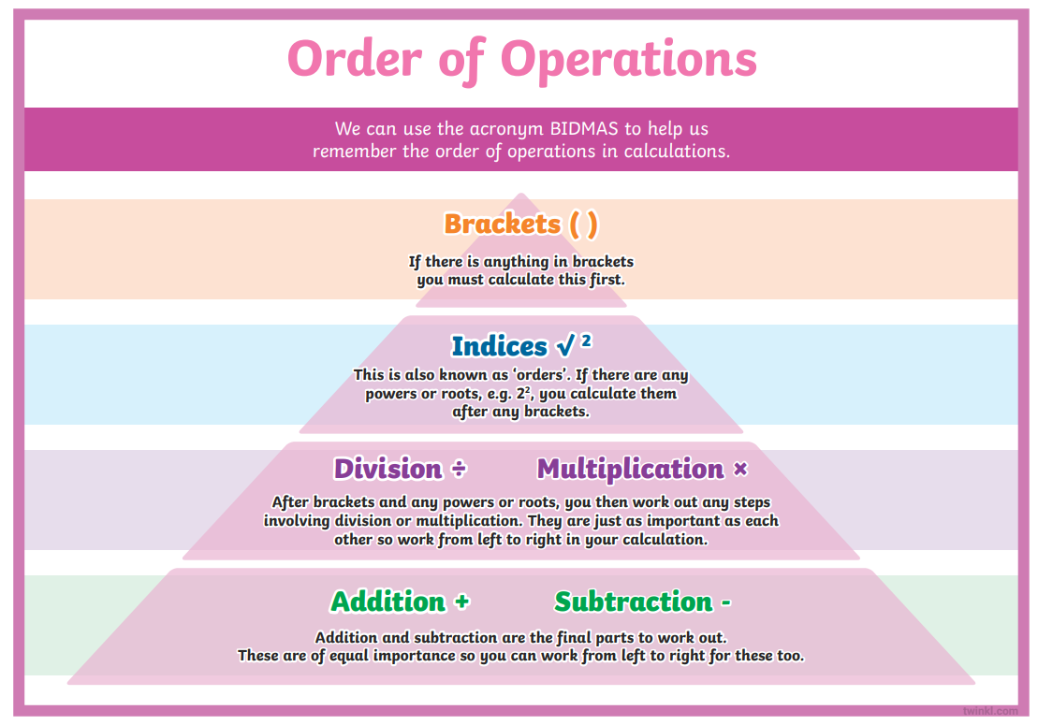 |  |  |  |  |  | 

