Y1 DIVISION
The children need to use concrete objects, pictorial representations (including a Tens frame) and arrays with the support of the teacher.

MENTAL METHODS  WITH JOTTINGS | Concept of Sharing  If I share 12 sweets by 2 people, how many sweets will each person get?  12 ÷ 2 = 6  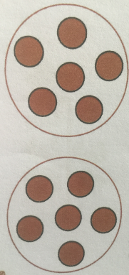  Low cognitive load |  | Concept of Grouping  How many groups of 2 can I make with 12 sweets?  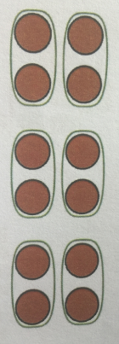  12 ÷ 2 = 6 |  |  | Learn HALVES TO 20 off by heart.  Half of 20 = 10  Half of 18= 9  Half of 16 = 8  Half of 14 = 7  Half of 12 = 6  Half of 10= 5  Half of 8 = 4  Half of 6 = 3  Half of 4 = 2  Half of 2 = 1
Y2 DIVISION
MENTAL METHODS  WITH JOTTINGS | Children need to recall division facts for the x2 x5 and x10 multiplication tables with speed and accuracy. | Calculate mathematical statements  using x ÷ and = signs  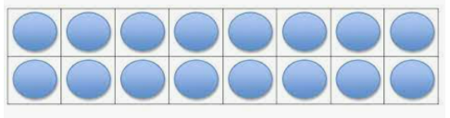  How many groups of 2 can you see in this array?  16 ÷ 2 = 8  16 ÷ 8 = 2  8 x 2 = 16  2 x 8 = 16  Know that multiplication of numbers can be done in any order but division of one number by another cannot. |  |  | Count in multiples on fingers  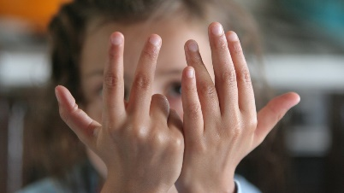  30 ÷ 5 =  How many groups of 5 can I make with 30?  - Count in multiples of 5  - Raise one finger for each multiple of 5.  - Keep counting until you reach the total of 30.  - Record how many fingers you have raised. |  | Learn halves of multiples 10 up to 50 off by heart.  Half of 100 = 50  Half of 90 = 45  Half of 80 = 40  Half of 70 = 35  Half of 60 = 30  Half of 50 =25  Half of 40 = 20  Half of 30 = 15  Half of 20 =10  Half of 10 = 5
Dividing in different contexts:  Examples of KS1 SATs questions involving division. | 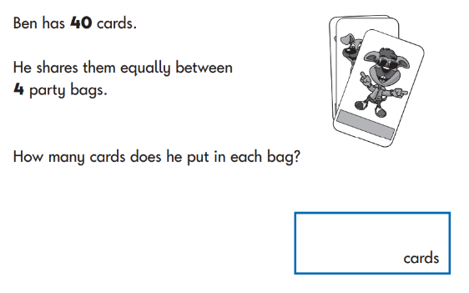 |  |  | 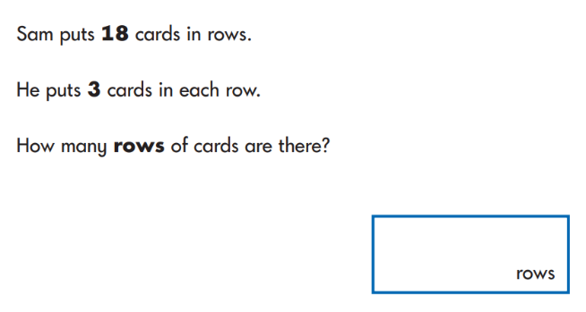 |  |  |  | 

