Y3 DIVISION
MENTAL METHODS  WITH JOTTINGS | Children need to recall division facts for the x3 x4 and x8 multiplication tables with speed and accuracy.  Use a range of strategies to develop speed and accuracy of recall:  Times tables rockstars Jamming Sessions (set to division facts)  Online hit the button game (set to division facts)  Quick fire responses  and so on… | Relate division to counting and multiplication facts.  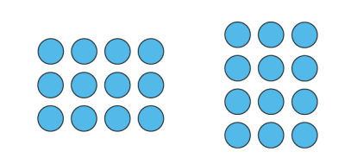  3 x 4 = 12  4 x 3 = 12  12 ÷ 3 = 4  12 ÷ 4 = 3 |  |  |  | Children need to practise relating known facts regularly: USE WHAT YOU KNOW  32 ÷ 8 = 4  320 ÷ 8 = 40  What easier fact could you use to calculate 240 ÷8 mentally?  24 ÷ 8= 3  240 ÷ 8 = 30 |  |  |  | Teach children a range of useful multiplication strategies:  HALVING with partitioning  Half of 496=  400 + 90 + 6  200 + 45 + 3 = 248  DIVIDING BY 4  Halve and halve again  68 ÷ 4 =  Half of 68 = 30 + 4 = 34  Half of 34 = 15 +2 =17 |  |  |  |  |  | Teach children how to round up or down in context.  There are 13 scouts on an adventure weekend. 3 scouts can sleep in each tent. How many tents will be needed for the scouts to sleep in?  13 ÷ 3 = 4 r 1  so round up to 5 tents so no scouts get wet!
MENTAL METHODS  WITH JOTTINGS | Use a range of strategies to develop speed and accuracy of recall:  Times tables rockstars Jamming Sessions (set to division facts)  Online hit the button game (set to division facts)  Quick fire responses  and so on… | Continue to use arrays so that children can visualise and relate fact families. |  |  |  | We DO NOT teach children to ‘remove a zero’ when dividing by 10. We teach children that when we make a number 10 x smaller we move the digit one place down the place value chart.  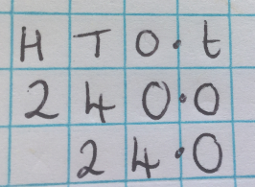  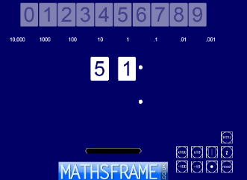  We use the Moving Digits ITP tool to demonstrate this.
FORMAL WRITTEN  METHODS |  | Dividing TO by O  (Within taught times tables ÷3 ÷ 4 ÷5 ÷8)  68 ÷ 5 =  Partition 68 in a different way to help us use our x 5 facts  50 + 10+ 5 + 3 =  Or  30 + 30 + 5 + 3 =  Then you can calculate how many groups of 5 (the divisor) we can make and how many are left over (remainder).  30 + 30 + 5 + 3 =  6 + 6 + 1 + r3 = 13 r3 |  |  |  |  |  | Teach formal short division in Summer Term in readiness for Y4.  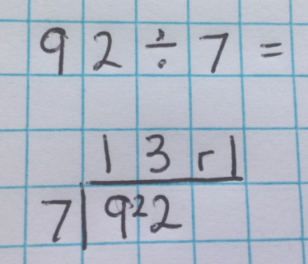  Put division calculations into a story context to aid understanding.  There are 92 unicorns in the magical forest. The wizard has to group the unicorns equally between the stables overnight. How many unicorns be in each stable? How many will be left over and have to go home with the wizard? |  |  |  |  |  |  | The number we are dividing by is called the DIVISOR. We are dividing by 7. The divisor is 7.  Start the formal method by asking, “How many groups of 7 can we make with 9?  The amount that is left over is called a REMAINDER.
Y4 DIVISION
MENTAL METHODS  WITH JOTTINGS |  | Children need to recall division facts for the x3 x4 and x8 multiplication tables with speed and accuracy. |  | Children need to practise relating known facts regularly: USE WHAT YOU KNOW  42 ÷ 6 = 7  420 ÷ 6 = 70  4200 ÷ 6 = 700  What easier fact could you use to calculate 5600 ÷ 7 mentally?  56 ÷ 7 = 8  5600 ÷ 7 = 800 |  |  | Teach children a range of useful multiplication strategies:  DIVIDING 2-digit numbers BY 10  Move the digits 1 place down the place value chart.  (see note below)  45÷10=4.5  DIVIDING 2-digit numbers BY 100  Move the digits 2 places down the place value chart.  (see note below)  53÷100=0.53  HALVING with partitioning  Half of 1534=  1000 + 500 + 30 + 4=  500 + 250 + 15 + 2 = 767  DIVIDING BY 4  Halve and halve again  256 ÷ 4 =  Half of 256 = 100+25+3=128  Half of 128 = 50+10+4=64 |  |  |  | Continue dividing TO by O by partitioning a number in different ways as in Y3.  68 ÷ 5 =  Partition 68 in a different way to help us use our x 5 facts  60 + 5 + 3 =  Or  30 + 30 + 5 + 3 =  Then you can calculate how many groups of 5 (the divisor) we can make and how many are left over (remainder).  30 + 30 + 5 + 3 =  6 + 6 + 1 + r3 = 13 r3 |  |  |  |  |  | Teach children how to round up or down in context.  There are 65 scouts on an adventure weekend. 7 scouts can sleep in each tent. How many tents will be needed for the scouts to sleep in?  65÷7=9r2  so round up to 10 tents so no scouts get wet!
 |  | Use a range of strategies to develop speed and accuracy of recall:  Times tables rockstars Jamming Sessions (set to division facts)  Online hit the button game (set to division facts)  Quick fire responses  and so on… |  | We DO NOT teach children to ‘remove 2 zeros’ when dividing by 100. We teach children that when we make a number 100 x smaller we move the digits two places down the place value chart.  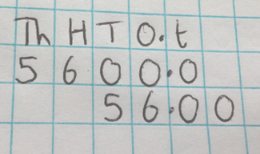  We use the Moving Digits ITP tool to demonstrate this.  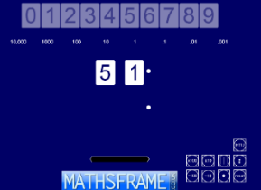
FORMAL WRITTEN  METHODS |  | Short Division  TO ÷ O =  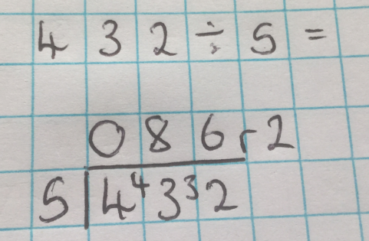  HTO ÷ O =  Put division calculations into a story context to aid understanding  There are 432 penguins that need to be grouped equally on 5 icebergs.  How many penguins can nest on each iceberg? How many will be left swimming in the water? |  |  |  |  |  |  |  |  |  | The number we are dividing by is called the DIVISOR. We are dividing by 5. The divisor is 5.  Start the formal method by asking, “How many groups of 5 can we make with 4?  The amount that is left over is called a REMAINDER.
Y5 DIVISION
MENTAL METHODS  WITH JOTTINGS |  | Continue practising rapid recall of division facts for multiplication tables to 12 x 12 |  |  | Children need to practise relating known facts regularly: USE WHAT YOU KNOW  49 ÷ 7 = 7  490 ÷ 7 = 70  4900 ÷ 7 = 700  4.9 ÷ 7= 0.7  What easier fact could you use to calculate 5600 ÷ 7 mentally?  56 ÷ 7 = 8  5600 ÷ 7 = 800 |  |  | Teach children a range of useful multiplication strategies:  DIVIDING whole numbers and decimals BY 10, 100 and 1000  (see note below)  Move the digits one place down the place value chart  675÷10=6.75  5.67÷10=0.56  Move the digits two places down the place value chart  6578÷100=65.78  117.2÷ 100=1.172  Move the digits three places down the place value chart  72855÷1000=72.855  117.8÷1000=0.1178  HALVING with partitioning  Half of 5794=  5000 + 700 + 90 + 4 =  2500 + 350 + 45 + 2 = 2897  DIVIDING BY 4  Halve and halve again  676 ÷ 4 =  Half 676 = 300+35+3=338  Half of 338=150+15+4=169 |  |  |  |  |  | Teach children how to round up or down in context.  There are 112 scouts on an adventure weekend. 8 scouts can sleep in each tent. How many tents will be needed for the scouts to sleep in?  112 ÷ 8 = 15r2  so round up to 16 tents so no scouts get wet!
 |  | Use a range of strategies to develop speed and accuracy of recall:  Times tables rockstars Jamming Sessions (set to division facts)  Online hit the button game (set to division facts)  Quick fire responses  and so on… |  |  | We DO NOT teach children to ‘remove 2 zeros’ when dividing by 100. We teach children that when we make a number 100 x smaller we move the digits two places down the place value chart.  We use the Moving Digits ITP tool to demonstrate this.
FORMAL WRITTEN  METHODS |  | Short Division  TO÷O=  HTO÷O=  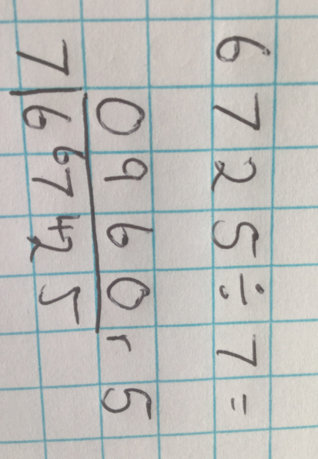  ThHTO÷O=  Put division calculations into a story context to aid understanding  There are 6725 pencils that need to be grouped equally between 7 crates. How many pencils will be in each crate? How many pencils will be left over? |  |  |  |  |  | The number we are dividing by is called the DIVISOR. We are dividing by 7. The divisor is 7.  Start the formal method by asking, “How many groups of 7 can we make with 6?  The amount that is left over is called a REMAINDER. |  |  |  |  | Teach children how to interpret remainders appropriately for the context.  98 ÷ 4 = 24r2  Interpret as a fraction = 24 ½  Interpret as a decimal = 24.5  Round up to 25  Round down to 24
Y6 DIVISION
MENTAL METHODS  WITH JOTTINGS  All mental methods as in Y5 and… |  |  | Use their knowledge of the order of operations to carry out calculations involving any of the four operations.  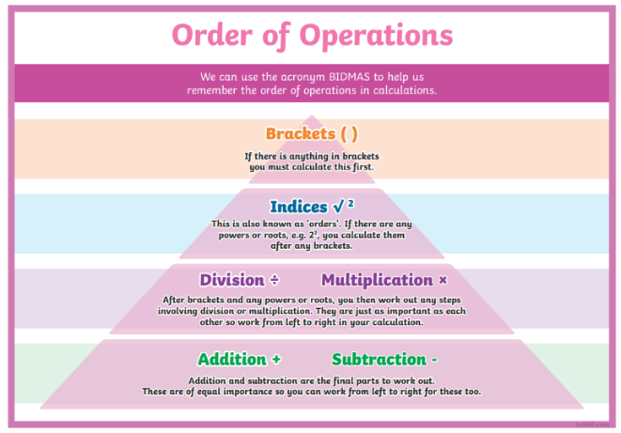  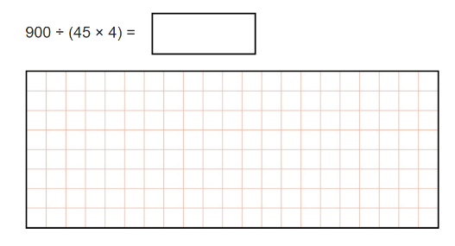 |  |  |  |  |  | Know some divisibility statements.  A number is divisible by 3 when the sum of all the digits are divisible by 3.  723  7+2=3=12  723 is a multiple of 3  A number is divisible by 4 when the last 2 digits are divisible by 4  85,632  32÷4=8  85,632 is divisible by 4  A number is divisible by 6 when it is even AND the sum of all the digits are divisible by 3.  834  834 is even  8+3+4=15  834 is a multiple of 6  A number is divisible by 9 when the sum of its digits are divisible by 9.  1872  1+8+7+2 =18  1872 is a multiple of 9
FORMAL WRITTEN  METHODS  All formal methods from Y5 and… |  |  | Long Division  HTO÷TO=  ThHTO÷TO=  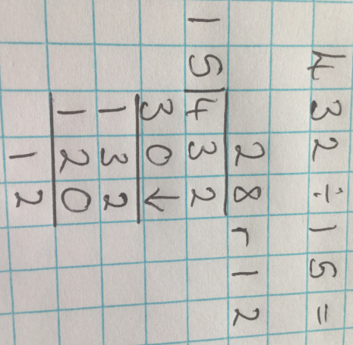  Teach children how to interpret remainders appropriately for the context.  28 r12  Interpret as a fraction = 28 12/15= 28 4/5  Interpret as a decimal = 28.8 because 4/5 as a decimal is 0.8  Round down to 28  Round up to 29 |  |  |  |  |  | 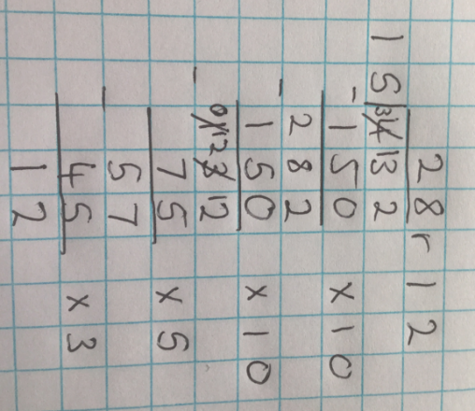  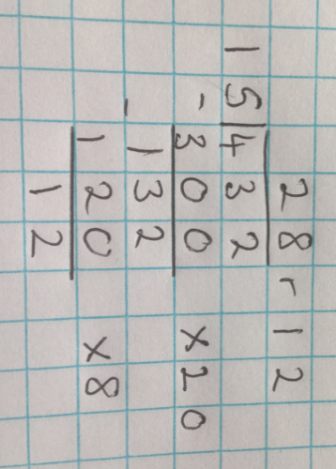  Chunking Method  or

