Y1 MULTIPLICATION
Children need lots of experience of counting in twos, fives and tens. Use a range of concrete objects and pictorial representations to support calculations.

- Tens frames
- Multi-link
- Abacus beads
- Number tracks
- Number lines
- Coins

MENTAL METHODS  WITH JOTTINGS | Count in multiples of twos, fives and tens.  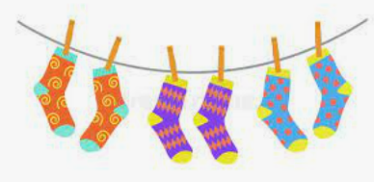  How many pairs of socks can you count?  2 + 2 + 2 = 6 (repeated addition)  3 lots/sets/groups of 2 = 6  leading to…  3 times 2  3 multiplied by 2  3 x 2=6  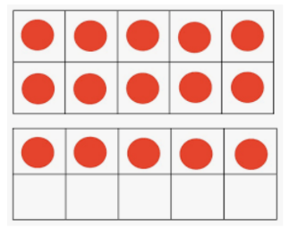  How many groups of 5 can you see on the tens frames?  5 + 5 + 5 = 15  3 lots/sets/groups of 5 = 15  leading to…  3 times 5 = 15  3 multiplied by 5 is 15  3 x 5 = 15 |  |  | Recognise patterns in the number system, for example, odd and even numbers.  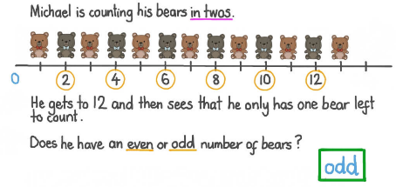 |  | Begin to use arrays to understand that multiplication can be done in any order.    4 x 2= 8  2 x 4 = 8 |  |  | Learn DOUBLES TO 10 off by heart.  Double 1 = 2  Double 2 = 4  Double 3 = 6  Double 4 = 8  Double 5 = 10  Double 6 = 12  Double 7 = 14  Double 8 = 16  Double 9 = 18  Double 10 = 20
Y2 MULTIPLICATION
MENTAL METHODS  WITH JOTTINGS | Children must know their x2, x5 and x10 multiplication facts up to 12 x off by heart by the time they leave Y2.  STEP 1  Learn to count in multiples: 0, 5, 10, 15…  STEP 2  Say the times table in order: 0x5=0, 1x5=5, 2x5=10, 3x5=15…  STEP 3  Learn the facts off by heart to recall in a random order: 6x5=30, 9x5=45 | Teach children that multiplication can be done in any order.  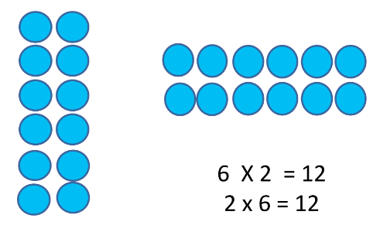 |  |  | Use arrays so that children can visualise and relate fact families.    6 x 5 = 30  5 x 6 = 30  30 ÷ 5 = 6  30 ÷ 6 = 5 |  |  | Learn doubles of multiples of 5 and 10 up to 50 off by heart.  Double 10=20  Double 15=30  Double 20=40  Double 25=50  Double 30 = 60  Double 35= 70  Double 40 = 80  Double 45=90  Double 50=100
MENTAL METHODS  WITH JOTTINGS | Use a range of strategies to develop speed and accuracy of recall:  - Times tables rockstars Jamming Sessions  - Online hit the button game  - Oral counting as a class on counting stick/counting hoop  - Oral counting in small groups  - Timed multiplication grids and so on
Multiplying in different contexts:  Examples of KS1 SATs questions involving multiplication. | 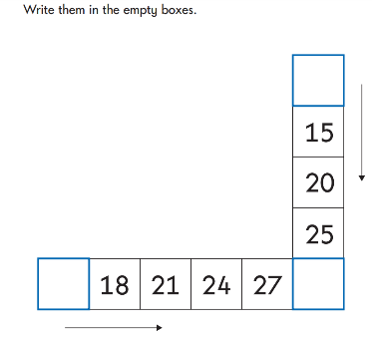 |  | 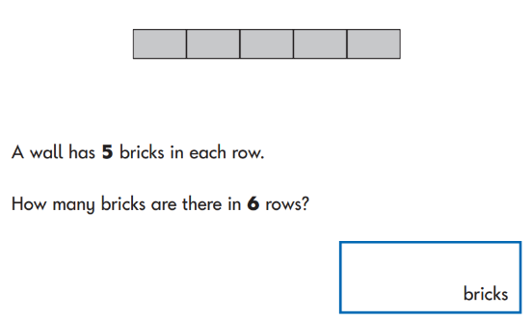 |  |  |  | 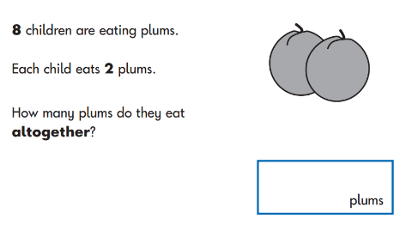 |  |  | 

