Y3 MULTIPLICATION
MENTAL METHODS  WITH JOTTINGS | Children will practise counting in multiples of 6, 7 9, 25 and 1000 regularly.  Recognise that:  Multiples of 2 end in 0, 2, 4 , 6 or 8 (even numbers)  Multiples of 10 end in 0  Multiples of 5 end in o or 5  Multiples of 100 end in 00  Multiples of 1000 end in 000  Multiples of 25 end in 00, 25, 50 or 75 | Children must know their x3 x4 and x8 multiplication facts off by heart by the time they leave Y3.  STEP 1  Learn to count in multiples: 0, 4, 8, 12…  STEP 2  Say the times table in order: 0x4=0, 1x4=4, 2x4=8, 3x4=12…  STEP 3  Learn the facts off by heart to recall in a random order: 6x4=24, 9x4=3 |  |  |  | Teach children that multiplication can be done in any order:  3x4=12 and 4x3=12  And  4 x 12 x 5=  4 x 5 x 12=  20 x 12=240 |  |  |  |  | Children need to practise relating known facts regularly: USE WHAT YOU KNOW  6 x 4 = 24  6 x 40 = 240  What easier fact could you use to calculate 6 x 30 mentally?  6 x 3= 18  6 x 3 = 180 |  |  |  |  | Teach children a range of useful multiplication strategies:  MULTIPLYING BY 4  Double and double again  13 x 4 =  Double 13 = 26  Double 26 = 52  MULTIPLYING BY 8  Double, double and double again  15 x 8 =  Double 15 = 30  Double 30 = 60  Double 60 = 120  MULTIPLYING BY 5  Multiply by 10 and halve the answer  34 x 5 =  34 x 10=340  Halve of 340 = 150 + 20 = 170  MULTIPLYING BY 20  Multiply by 10 and then double the answer  12 x 20 =  12 x 10 = 120  Double 120 = 240
MENTAL METHODS  WITH JOTTINGS |  | Use a range of strategies to develop speed and accuracy of recall:  - Times tables rockstars Jamming Sessions  - Online hit the button game  - Oral counting as a class on counting stick/counting hoop  - Oral counting in small groups  - Timed multiplication grids and so on |  |  |  | Continue to use arrays so that children can visualise and relate fact families.  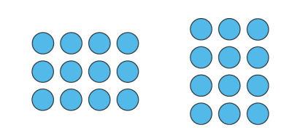  3 x 4 = 12  4 x 3 = 12  12 ÷ 3 = 4  12 ÷ 4 = 3 |  |  |  |  | 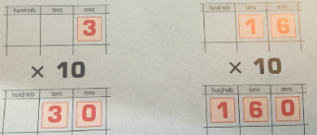  We DO NOT teach children to ‘add a zero’ when multiplying by 10. We teach children that when we make a number 10 x larger we move the digit one place up the place value chart.  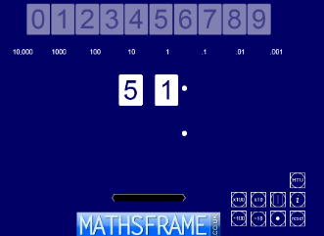  We use the Moving Digits ITP tool to demonstrate this.
FORMAL WRITTEN  METHODS |  | Multiplying TO by O  (Within taught times tables x3, x4, x5 x8)  45 x 3 =  40 x 3 = 120  5 x 3 = 15  120 + 15 = 135 |  |  |  |  |  |  | Teach formal short multiplication in Summer Term in readiness for Y4.  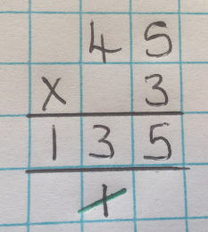 |  |  |  |  |  | Estimate before calculating.  50 x 3 = 150  Carried digits are written under the line.  Cross of the carried digits once they have been added.
Y4 MULTIPLICATION
MENTAL METHODS  WITH JOTTINGS |  | Children must know their multiplication facts to 12 x 12 off in readiness for the Multiplication Tables Check (MTC) in Summer 1.  Keep revising: x2, x5, x3, x4, x8 from previous years.  Teach children to speedily recall the  6 FACT CHALLENGE off by heart. These are 6 new facts that have not yet been taught.  6x6=36  6x7=42  7x7=49  9x6=54  9x7=63  9x9=81  Continue to practise x6, x7, x9,  STEP 1  Learn to count in multiples: 0, 6, 12, 18…  STEP 2  Say the times table in order: 0x6=0, 1x6=4, 2x6=12, 3x6=18…  STEP 3  Learn the facts off by heart to recall in a random order: 6x6=36, 9x6=54  Then teach x11 and x12 facts |  | Teach children useful strategies for multiplying by 9:  - Using the finger method  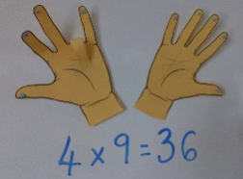  - X by 10 and then adjust  9 x 6 =  10 x 6 = 60  60 – 6 = 54  - Know the digits in the answers to x9 table always add up to 9…  So 6 x 9 must be ’50 something’.  6 x 9 = 54 because digits 5 + 4 = 9  - Look for patterns. There is symmetry in the list of multiples.  09, 18, 27, 36, 45 matches to 54, 63, 72, 81, 90 |  |  |  |  |  | Children need to practise relating known facts regularly: USE WHAT YOU KNOW  7 x 6 = 42  7 x 60 = 420  7 x 600 = 4200  What easier fact could you use to calculate 9 x 600 mentally?  9 x 6 = 54  9 x 600 = 5400 |  |  |  |  |  |  | Continue to teach children a range of useful multiplication strategies:  MULTIPLYING BY 4  Double and double again  36 x 4 =  Double 36 = 72  Double 72 = 144  MULTIPLYING BY 8  Double, double and double again  27 x 8 =  Double 27 = 54  Double 54 = 108  Double 108 = 216  MULTIPLYING BY 5  Multiply by 10 and halve the answer  69 x 5 =  69 x 10=690  Halve of 690 = 300 + 45 = 345  MULTIPLYING BY 20  Multiply by 10 and then double the answer  48 x 20 =  28 x 10 = 480  Double 480 = 800 + 160 = 960
 |  | Use a range of strategies to develop speed and accuracy of recall:  - Times tables rockstars Jamming Sessions  - Online hit the button game  - Oral counting as a class on counting stick/counting hoop  - Oral counting in small groups  - Timed multiplication grids and so on |  |  |  |  |  |  |  | We DO NOT teach children to ‘add zeros’ when multiplying by 10 or 100. We teach children that when we make a number 10 x larger we move the digit one place up the place value chart. When we make a number 100 x larger we move the digit two places up the place value chart.  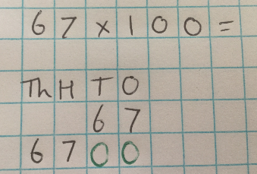  We use the Moving Digits ITP tool to demonstrate this.  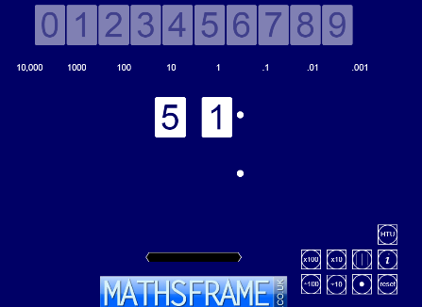
FORMAL WRITTEN  METHODS |  | Multiplying 2-digit by 1-digit numbers  Continue practising the distributive law taught in Y3:  57 x 6 =  50 x 6 + 7 x 6 =  300 + 42 = 342  Formal short multiplication  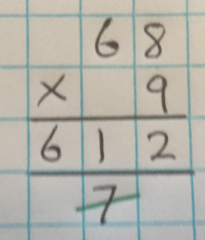  Estimate before calculating.  70 x 9 = 630  Carried digits are written under the line.  Cross of the carried digits once they have been added. | 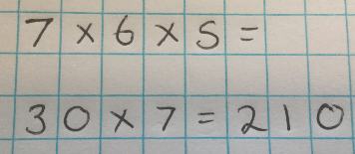  Multiplying together 3 numbers  Teach how to use factor pairs when multiplying:  6 x 3 x 12  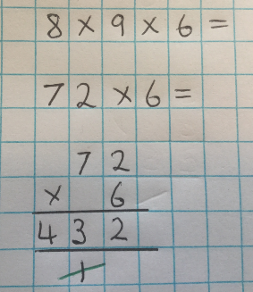  6 x 3 =18  18 x 10 x 2 =  180 x 2 = 360  Choose efficient method: |  |  |  |  |  |  |  |  | Multiplying 3- digit by 1-digit numbers  Formal short multiplication  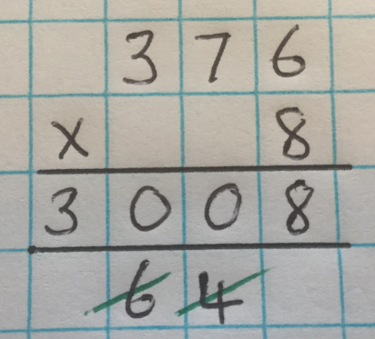  Estimate before calculating.  400 x 8 = 3200  Carried digits are written under the line.  Cross of the carried digits once they have been added.
Y5 MULTIPLICATION
MENTAL METHODS  WITH JOTTINGS |  | Continue practising rapid recall of multiplication facts to 12 x 12  Learn square number facts OFF BY HEART  1²=1  2² =4  3² = 9  4² =16  5² = 25  6² = 36  7²= 49  8² = 64  9²=81  10² = 100  11²= 121  12²=144 |  |  | Children need to practise relating known facts regularly: USE WHAT YOU KNOW  8 x 7 = 56  8 x 70 =560  8 x 700 = 5600  8 x 7000 = 56,000  8 x 0.7 = 5.6  8 x 0.07 = 0.56  What easier fact could you use to calculate 9 x 700 mentally?  9 x 7 = 63  9 x 700 = 6300 |  |  | Continue to teach children a range of useful multiplication strategies:  MULTIPLYING BY 10, 100 and 1000 (whole numbers and decimals)  See note below  MULTIPLYING BY 4  Double and double again  76 x 4 =  Double 76 = 152  Double 152 = 304  MULTIPLYING BY 8  Double, double and double again  63 x 8 =  Double 63 = 126  Double 126 = 252  Double 252 = 504  MULTIPLYING BY 5  Multiply by 10 and halve the answer  86 x 5 =  86 x 10 = 860  Halve of 860 = 400 + 30 = 430  MULTIPLYING BY 50  Multiply by 100 and halve the answer.  36 x 50=  36 x 100 = 3600  Halve of 3600 = 1500 + 300 = 1800  MULTIPLYING BY 20  Multiply by 10 and then double the answer  57 x 20 =  57 x 10 = 570  Double 570 = 1000 + 140 = 1140 |  |  |  |  |  | Teach how to use factor pairs when multiplying.  345 x 12 =  345 x 10 x 2 =  3450 x 2 = 6900  Or  1342 x 18 =  1342 x 10 x 8 =  13420 x 8 =  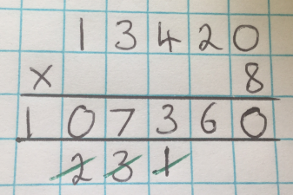
 |  | Use a range of strategies to develop speed and accuracy of recall:  - Times tables rockstars  - Online hit the button game  - Oral counting as a class on counting stick/counting hoop  - Oral counting in small groups  - Timed multiplication grids and so on |  |  | We DO NOT teach children to ‘add zeros’ when multiplying by 10 or 100. We teach children that when we make a number 10 x larger we move the digit one place up the place value chart. When we make a number 100 x larger we move the digit two places up the place value chart. When we make a number 1000 times larger we move the digits three places up the place value chart.  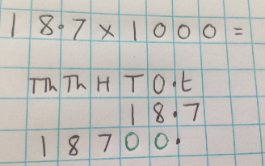  We use the Moving Digits ITP tool to demonstrate this.  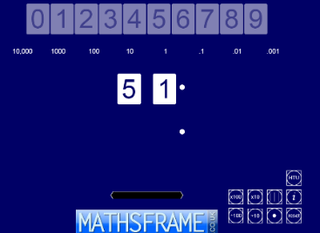
FORMAL WRITTEN  METHODS |  | Short Multiplication: multiply numbers up to 4 digits long by 1-digit number.  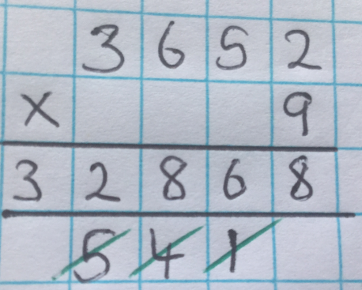  Estimate before calculating.  4000 x 9 = 3600  Carried digits are written under the line.  Cross of the carried digits once they have been added. |  |  |  |  |  | Long Multiplication: multiply numbers up to 4-digits long by 2-digit numbers.  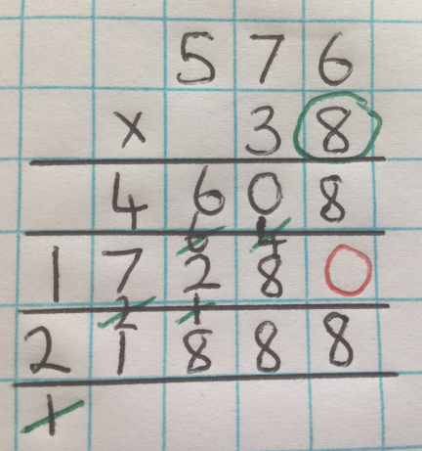  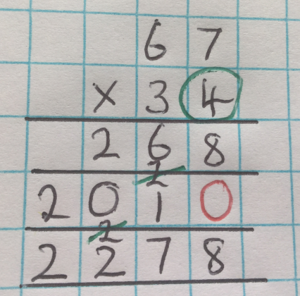  Estimate before calculating.  Circle the lower ones digit as a starting point.  Carried digits are written neatly and precisely on the line underneath to make sure other digits are clear.  Cross of the carried digits once they have been added.  Explain that when we multiply by the Tens digit we must write a zero in the ones column to act as a place holder. This makes sure the digits are 10 x bigger as they are being moved one place up the place value headings.
Y6 MULTIPLICATION
All mental and formal methods as in Y5 and…  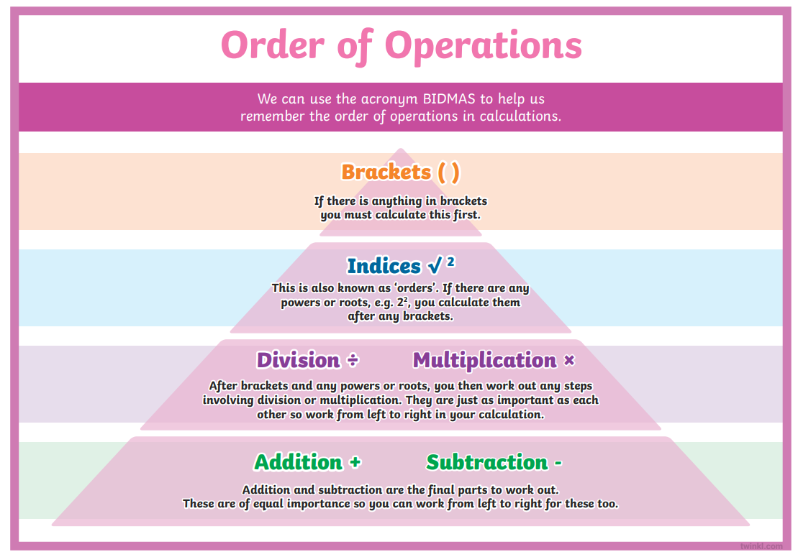  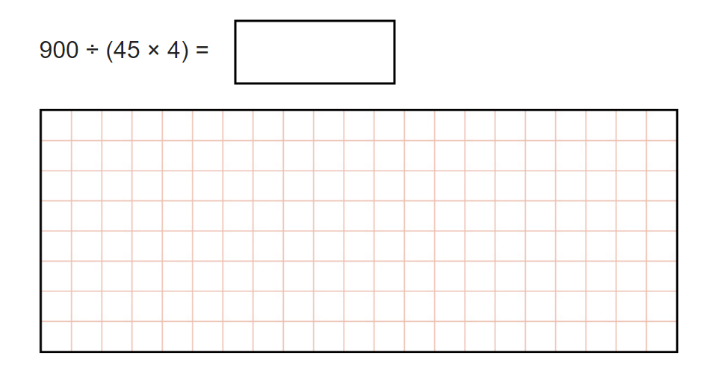 |  |  |  |  |  |  | Multiply a decimal number with up to 2 decimal places by a 1-digit number.  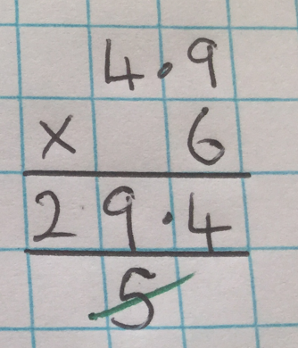  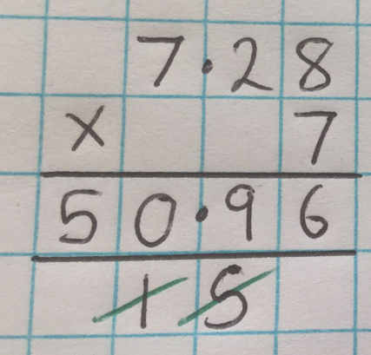  Estimate before calculating.  Carried digits are written under the line.  Cross of the carried digits once they have been added. |  |  |  |  |  | Know some divisibility statements.  A number is divisible by 3 when the sum of all the digits are divisible by 3.  723  7+2=3=12  723 is a multiple of 3  A number is divisible by 4 when the last 2 digits are divisible by 4  85,632  32÷4=8  85,632 is divisible by 4  A number is divisible by 6 when it is even AND the sum of all the digits are divisible by 3.  834  834 is even  8+3+4=15  834 is a multiple of 6  A number is divisible by 9 when the sum of its digits are divisible by 9.  1872  1+8+7+2 =18  1872 is a multiple of 9

