Y1 SUBTRACTION
MENTAL METHODS  WITH JOTTINGS | 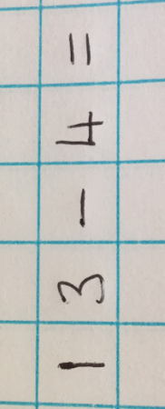  Counting back from the largest number in ones.  *Some children will naturally visualise bridging back through ten. This can be demonstrated using Tens frames and number lines  13 – 3 = 10  10 – 1 = 9 |  |  | Children need to memorise number bonds to 20 and relate subtraction to addition.  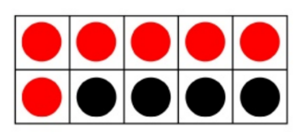  10 – 4 = 6  10 – 6 = 4  6 + 4 = 10  4 + 6 = 10  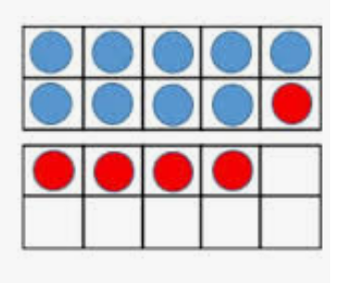  14 – 5 =  14 – 4 – 1 = 9 |  |  | 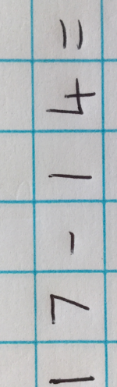  Count on from the smaller number to the larger number.  (Useful when the numbers are close together).
MENTAL METHODS  WITH JOTTINGS | 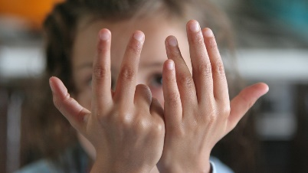  1) Children put largest number (13) in their head.  2) They raise the appropriate number of  fingers: 4 ones  3) They count back and put fingers down as  they count.  4) Record the answer. |  |  |  |  |  | - Children put smallest number (14) in their head.  - They raise fingers to count on until they reach largest number.  - Record the answer.
MISSING NUMBER  CALCULATIONS | 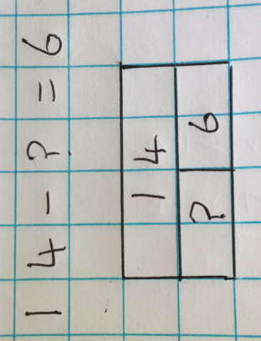  Whole Part Models  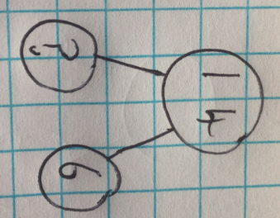  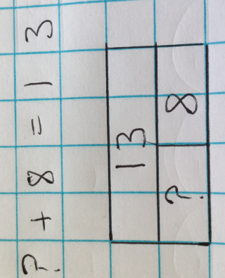  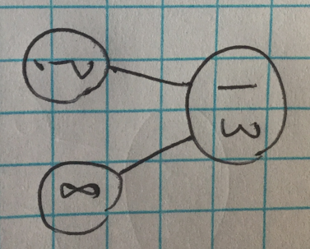 |  |  |  | Whole part models are especially useful when calculating the missing number in a calculation.  This model helps children to understand that these calculations both require subtraction.
Y2 SUBTRACTION
MENTAL METHODS  WITH JOTTINGS | Counting back from the largest number in ones.  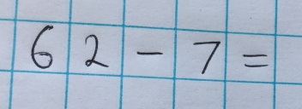  *Some children will naturally visualise bridging back through ten. This can be demonstrated using Tens frames and number lines.  62 – 2 = 60  60 – 5 = 55 | 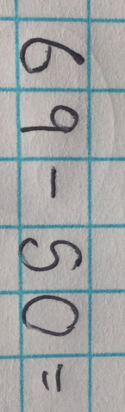  Counting back from the largest number in tens. |  |  |  | Count on from the smaller number to the larger number.  (Useful when the numbers are close together).  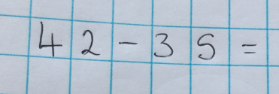 |  |  | 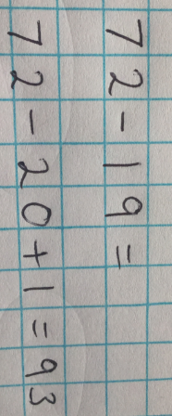  Adjusting  (Useful when subtracting numbers ending in 7, 8 or 9)
MENTAL METHODS  WITH JOTTINGS | Children put largest number (62) in their head.  2) They raise the appropriate number of  fingers: 7 ones  3) They count back and put fingers down as  they count.  4) Record the answer. | - Children put the largest number in their  head (69).  - They raise the appropriate number of fingers: 5 tens as in the above example.  - They count on in tens and put the fingers down as they count.  - Record the total |  |  |  | - Children put smallest number (35) in their head.  - They raise fingers to count on until they reach largest number (42).  - Record the answer. |  |  | Children record jottings if necessary. They can be supported initially with a hundred square but the aim is to calculate mentally.
WRITTEN  METHODS | Subtracting two 2-digit numbers: using an empty number line to show calculation.  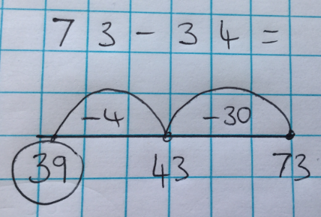
WRITTEN  METHODS | Can use a hundred square initially to support.  - Start with the largest number.  - Count back in tens  - Then count back in ones.  - Record the total.
MISSING NUMBER  CALCULATIONS | Whole Part Models  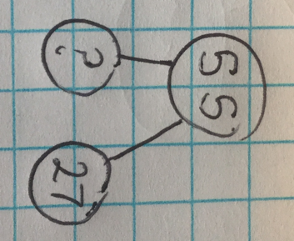  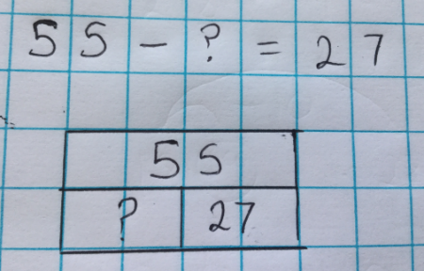  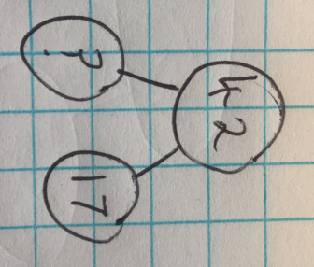  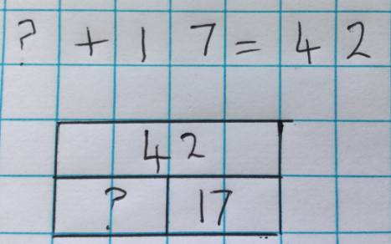 |  |  |  | Whole part models are especially useful when calculating the missing number in a calculation.  This model helps children to understand that this calculation requires addition even though there is a subtraction sign.
Subtracting in different contexts:  Examples of KS1 SATs questions involving subtraction. | 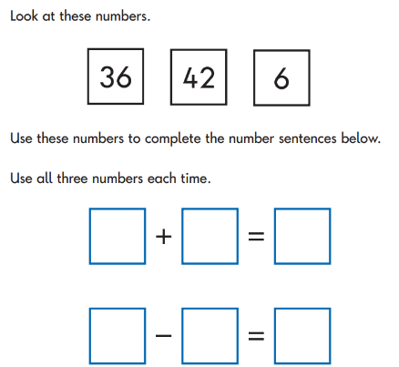 |  | 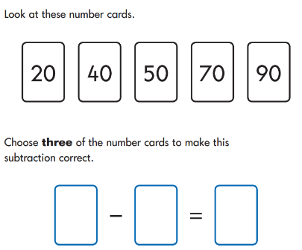 |  | 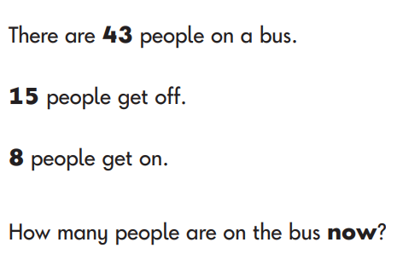 |  |  | 

