Y3 SUBTRACTION
MENTAL METHODS  WITH JOTTINGS | Counting back from the largest number in ones, tens and hundreds.  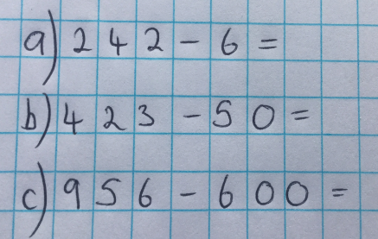 |  |  | Count back in jumps of hundreds/tens and ones.  (Useful when the jumps backwards are small).  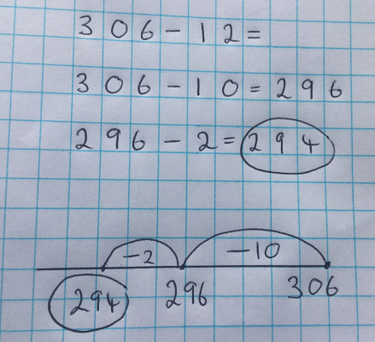 |  |  |  | Count on from the smaller number to the larger number.  (Useful when the numbers are close together).  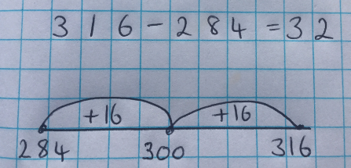 |  |  |  | Adjusting  (Useful when subtracting numbers ending in 7, 8 or 9).  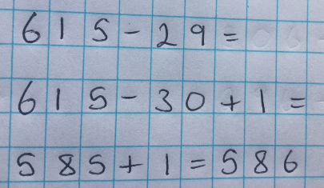  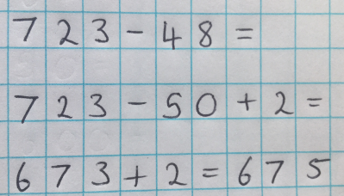
MENTAL METHODS  WITH JOTTINGS | 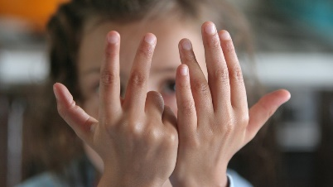  1) Children put largest number in their head.  2) They raise the appropriate number of  fingers: 6 ones. 5 tens, 6 hundreds (as in  the examples above)  3) They count back and put fingers down as  they count.  4) Record the answer. |  |  | Children record jottings if necessary. |  |  |  | Children record jottings if necessary. |  |  |  | Children record jottings if necessary.
FORMAL WRITTEN  METHODS | 3-digit subtract 2-digit, 3-digit subtract 3-digit  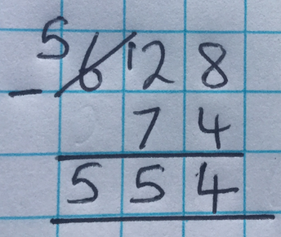  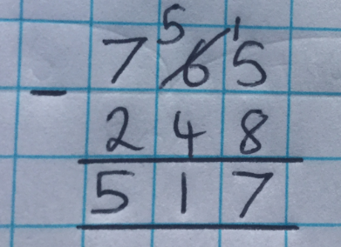 |  |  |  |  |  | - Children should be encouraged to estimate BEFORE calculating.  - Digits should be referred to by their value: 6 in the tens column is 6 TENS or 60 not 6.  - Numbers should be neatly crossed off and exchanged into previous place value column in subtraction calculations.  - Children should be encouraged to check their answer using the inverse subtraction calculation.
MISSING NUMBER  CALCULATIONS | 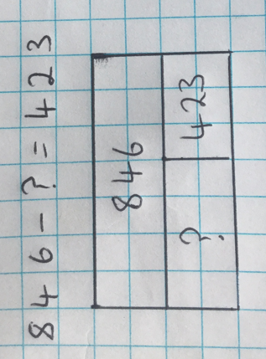  Whole Part Models  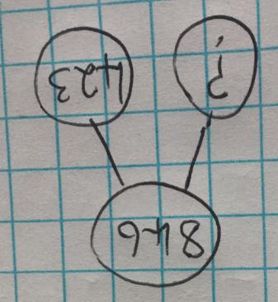  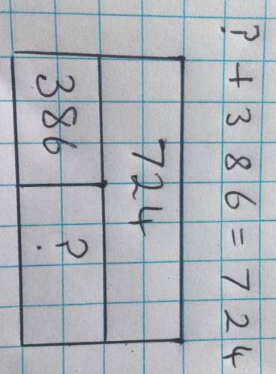  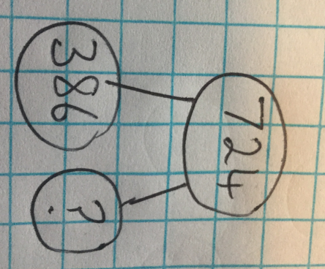 |  |  |  |  |  | Whole part models are especially useful when calculating the missing number in a calculation.  This model helps children to understand that these calculations both require subtraction.
Y4 SUBTRACTION
MENTAL METHODS  WITH JOTTINGS | Count back in jumps of hundreds/tens and ones.  (Useful when the jumps backwards are small).  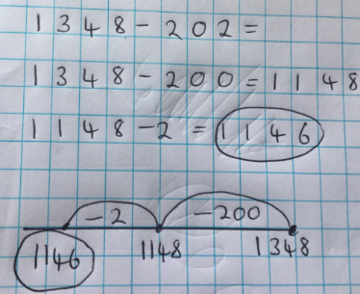 |  | Count on from the smaller number to the larger number.  (Useful when the numbers are close together).  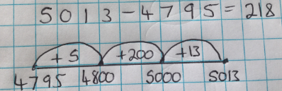 |  |  |  |  |  |  | Adjusting  (Useful when subtracting numbers ending in 7, 8 or 9).  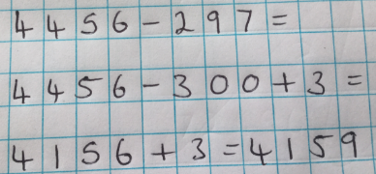  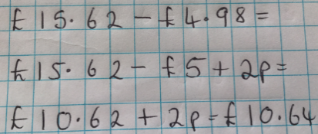 |  |  | Empty number lines are useful when counting back through zero and when decreasing time.  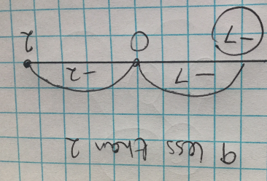  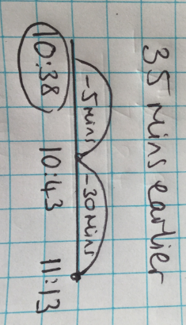
MENTAL METHODS  WITH JOTTINGS | Children record jottings if necessary. |  | Children record jottings if necessary. |  |  |  |  |  |  | Children record jottings if necessary. |  |  | Children record jottings if necessary.
FORMAL WRITTEN  METHODS | 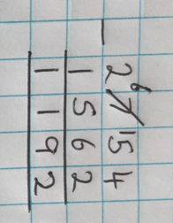  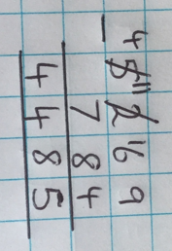  4-digit add 2-digit, 4-digit add 3-digit, 4-digit add 4-digit  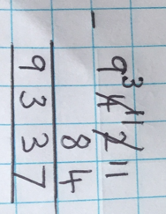  Decimals to 2DP  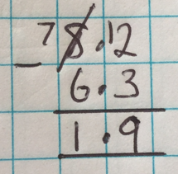  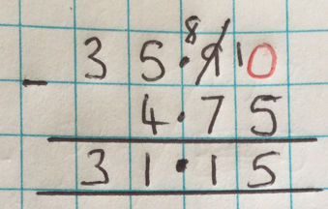  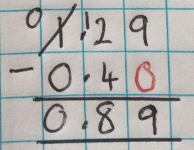 |  |  |  |  |  | - Children should be encouraged to estimate BEFORE calculating.  - Digits should be referred to by their value: 6 in the tens column is 6 TENS or 60 not 6.  - Numbers should be neatly crossed off and exchanged into previous place value column in subtraction calculations.  - Children should be encouraged to check their answer using the inverse subtraction calculation.  - When adding decimals of different decimal places mark the spaces with zeros. |  |  |  |  |  |  |  | Calculating change using a formal method.  Many children struggle when using a formal method to calculate change.  Rather than use method A, teach the children to take 1p from the amount they are spending AND the amount they are paying. This makes the calculation much easier.  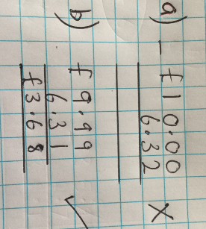
MISSING NUMBER  CALCULATIONS | Whole Part Models  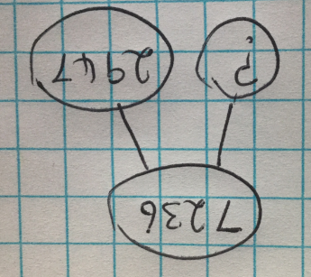  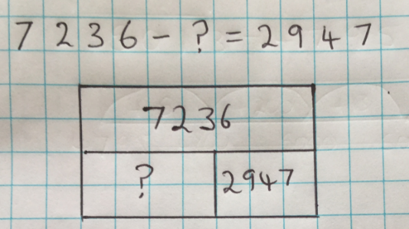  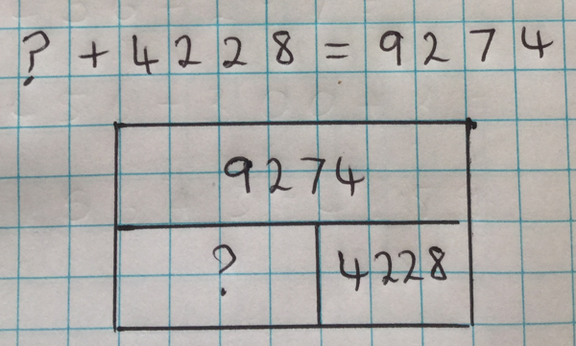  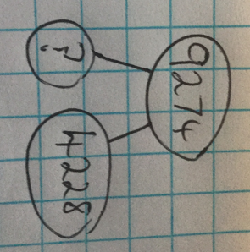 |  |  |  |  |  | Whole part models are especially useful when calculating the missing number in a calculation.  This model helps children to understand that this calculation requires addition even though there is a subtraction sign.
Y5 SUBTRACTION
MENTAL METHODS  WITH JOTTINGS |  | Count back in jumps of hundreds/tens and ones.  (Useful when the jumps backwards are small).  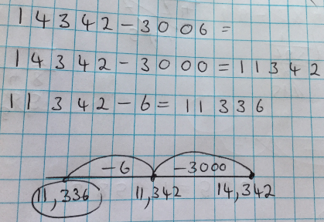 |  |  | Count on from the smaller number to the larger number.  (Useful when the numbers are close together).  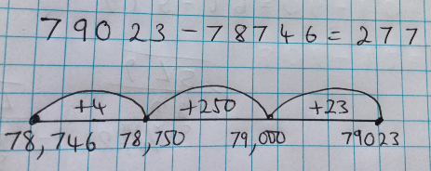 |  |  |  |  |  | Adjusting  (Useful when subtracting numbers ending in 7, 8 or 9).  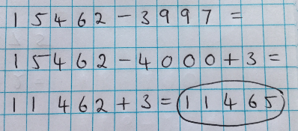  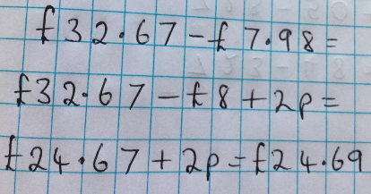 |  |  | 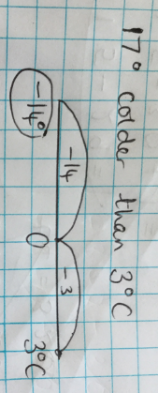  Empty number lines are useful when counting back through zero and when decreasing time.  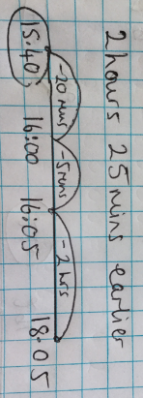
 |  | Children record jottings if necessary. |  |  | Children record jottings if necessary. |  |  |  |  |  | Children record jottings if necessary. |  |  | Children record jottings if necessary.
FORMAL WRITTEN  METHODS |  | More than 4 digits….  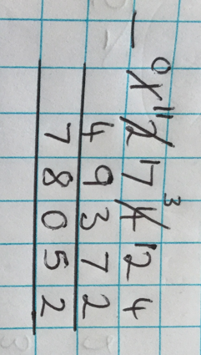  And so on…  Decimals to 3D  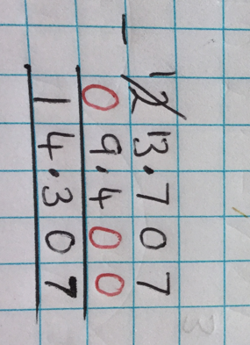  And so on… |  |  |  |  |  |  |  |  | - Children should be encouraged to estimate BEFORE calculating.  - Digits should be referred to by their value: 6 in the tens column is 6 TENS or 60 not 6.  - Numbers should be neatly crossed off and exchanged into previous place value column in subtraction calculations.  - Children should be encouraged to check their answer using the inverse subtraction calculation.  - When adding decimals of different decimal places mark the spaces with zeros. |  |  | Calculating change using a formal method.  Many children struggle when using a formal method to calculate change.  Rather than use method A, teach the children to take 1p from the amount they are spending AND the amount they are paying. This makes the calculation much easier.
MISSING NUMBER  CALCULATIONS |  | 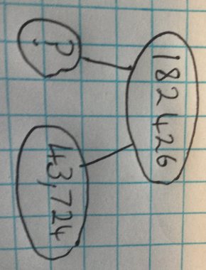  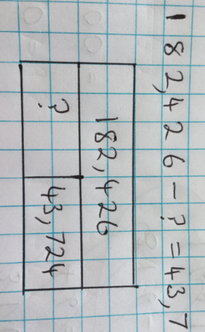  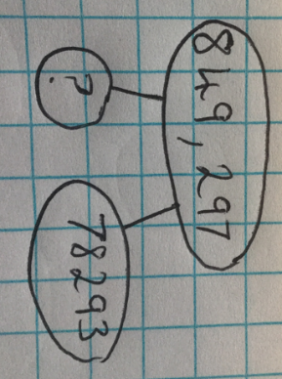  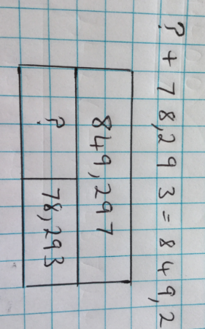 |  |  |  |  |  |  | Bar models are especially useful when calculating the missing number in a calculation.  This model helps children to understand that these calculations both require subtraction.
Y6 SUBTRACTION
As in Y5 and:  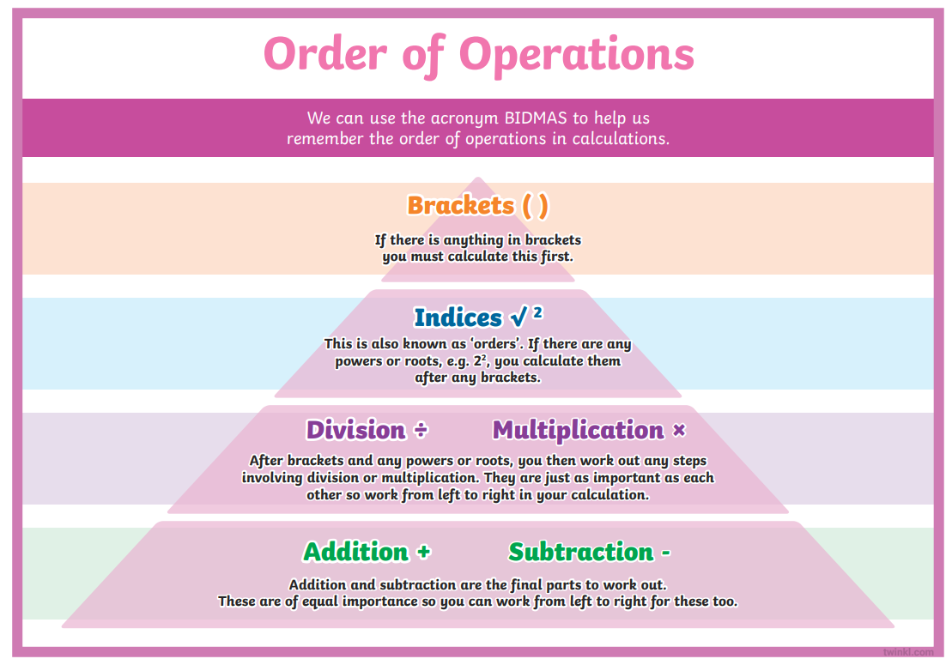 |  |  |  |  |  | 

